Reducing Humankind’s Ecological Footprint by Changing Energy Technology Submitted to the International Conference:
"Reconciling Human Existence and Ecological Integrity"
Global Ecological Integrity Group
Humboldt University, Berlin, July 16-20, 2008
by
Helmut Burkhardt
Professor of Physics Emeritus
Ryerson University, Toronto, Ontario, Canada
burkhard@ryerson.ca

Abstract
The ecological footprint of humankind at present is bigger than the ecologically productive area on this planet. In this situation we are destroying the integrity of ecosystems on a global scale. Nearly half of the ecological footprint calculated is due to carbon emissions of our fossil fuel based energy system. By changing to physically and technically feasible renewable energy resources other than biomass, the ecological footprint can be reduced, making a peaceful, sustainable civilization possible.

Is Homo Sapiens in trouble?
Food, water, and fuel scarcity exist around the globe. There is worldwide pollution of air, earth, and the oceans. Climate change, damaging extreme weather patterns, and sea level rise are cause for alarm. Deforestation, mass extinction of species of life is observed. The looming danger of epidemics, terrorism and the scourge of war are plaguing humankind. The global ecological footprint summarizes, and quantifies all these problems. Humankind’s footprint is 1.4 times bigger than the ecologically productive area that Planet Earth has to offer. (The Global Footprint Network 2008).
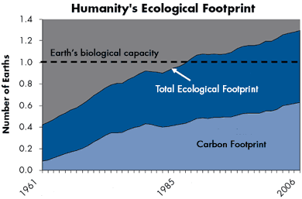
Therefore, our technology based civilization in its present form is not sustainable. Why is all this happening?

The Root Causes of Worldwide Problems:
Overpopulation, overconsumption, and inappropriate technology are the principal root causes of the global problems (Ehrlich and Holdren 1971). Each of these factors contribute to humanity’s impact on the environment. Furthermore, lack of good governance, and inappropriate social structures and values aggravate the situation. There is no global government to protect the global commons. The ubiquitous growth-is-good paradigm, the biblical be fruitful and multiply (King James Bible), and the hard to control genetically programmed urge to procreate all contribute to the collapse of civilization. Demographic and economic injustice is causing severe conflicts.
The Solution:

- Reduce world population.
While this is necessary for a long term solution, the challenging issue does not receive the attention it deserves.
- Reduce consumption.
Enhancing efficiency of use, and energy conservation is the most economic solution to humanities energy woes. Von Weizsaecker and Lovins (1998) are pioneers of this solution. Schmidt Bleek, the Factor 10 Institute (2008) goes even further in exposing the potential for energy and resource savings. However, these reduction factors are applicable only to the big consumers. The global average of 2.3 kW/capita is likely to increase. For the sake of global justice and equity, the poor should be allowed to increase energy consumption, and only the rich should reduce, and suggested by the contraction and convergence principle stated in the Kyoto Agreement. A reasonable total energy consumption of the future should not be much more than 3 kW/capita.
- Change Energy Technology.
This is a feasible short term solution, a temporary technical fix for the urgent worldwide problem of energy and climate change.
Nearly half of the ecological footprint is the carbon footprint, which comes from burning coal, oil and natural gas. Therefore, the human footprint can be cut in half by changing energy technology from fossil fuels to renewable energy resources.
It is a scientific certainty, that renewable energy resources can drive our technology based economy without fossil or nuclear fuels.

This is the good news. We do not have an energy resource crisis on this planet. It is a scientific fact, that renewable energy resources can replace fossil and nuclear fuels. This clearly shows the direction in which energy policy has to go in order to avoid a collapse of our technology based civilization.

Wind energy alone, a small byproduct of solar energy, has the potential to produce several times more energy than is required for sustaining our our economy. This is the conclusion of worldwide study at Stanford University. (Archer and Jacobson 2005) An article in the Economist (Economist 2007) describes how wind energy, combined with hydro-storage in Norway fjords, and high voltage DC transmission network across the continent could take centre stage in the future energy supply for Europe.

Solar power available at the surface of the Earth is about ten thousand times more than the total power derived from oil and nuclear resources. This should be common knowledge, but only few so far are fully conscious or this huge solar energy resource delivered free house. Some say it cannot replace fossil fuels or nuclear energy because it is not concentrated enough. The contrary is true. The global free distribution is a advantage over the concentrated resources such as nuclear or fossil fuels. Some say the low density of solar energy gives it less thermodynamic quality. This is wrong again, since the dilution of solar energy is reversible. Concentrated sunlight can produce a temperature of thousands of degrees. Hence sunlight has higher thermodynamic quality than oil or coal. Sunlight is a high quality energy; it has lower entropy or in other words, more exergy than fossil fuel based energy.

The immensity of the solar energy resource is shown in the following Earth map. The black dots give the extension of solar collectors required to supply all of humankinds present energy needs (Wikipedia 2008). Wikipedia gives a comprehensive survey of the power of the sun.
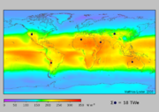

Geothermal energy is another clean, limitless resource that can be used for electricity production, direct use without first converting it to electricity, and more efficient home heating through geothermal heat pumps (US Government website 2008). The best geothermal potential for power generation is on the west side of South America, and on the East Africa. However, in combination with heat pumps geothermal energy for space heating is available around the globe. Recommendations for Geothermal energy are given by the International Geothermal Association (2005).

It is important, and essential to determine in which direction energy policy should go. The above list the main feasible energy options. However, of equal importance is to determine in which direction not to go.

Peaceful use of nuclear power makes nations vulnerable Burkhardt (2004), and is correlated strongly with nuclear weapons proliferation. The Wikipedia Article on dual use of technology describes this problem (Wikipedia 2008 b). A new generation of nuclear power plants is neither necessary, nor desirable.

Another unproductive option is the large scale use of biofuels. They are in strong competition with food production, and environmentally damaging. The quantity of fertile land necessary for replacing oil with agrofuels is not available. Presently, we have a global average of 1500 sqm of fertile land per person for food production. An additional 3000 sqm of agriculturally productive land per person would be needed to replace fossil fuels we arrive at the physical limits of our planet. (Burkhardt, 2007, Pimentel 2008).

By utilizing the renewable energy technologies, we can eliminate the carbon part of the footprint, which has been determined to be half of the total footprint calculated for humankind today (Wackernagel, 2008). The present footprint calculation is done by replacing fossil fuels with biofuels, and that procedure results in unsustainability, our need of 1.3 planets, when we have only one. This too shows the impossibility of replacing fossil fuels by large scale use of biofuels.

Implementation of Feasible Solutions

There are political, economic, social and cultural obstacles to changing a traditional technology. Lack of reliable knowledge, and vested interests in the status quo contribute to the social inertia that resists change.

In addition, issues such as climate change are highly complex and an accurate scientific prediction is impossible. Thus, the urgency for change is not clearly evident, there is a possibility of sceptics being right, and costly changes may be made in vain.

A timely opportunity to initiate change was lost in the oil crisis of the 1970s. President Carter had recognized the need for change and gave his famous ‘malaise speech’ on June 1979, where he proposed limitations to oil imports, rigorous conservation measures, and 20% of the US energy from solar resources. (Carter, 1979). Unfortunately, he lost the election to Ronald Reagan, who promised a rosy future to Americans.

Today, the energy crisis combined with climate change is seen by many as serious, and there is little hope that the high oil prices will fall again. The reports by the Intergovernmental Panel on Climate Change (2007) have convinced most media that climate change is a serious threat to sustainability of civilization. The world food crisis has shaken the confidence is a solution of energy and climate change through biofuels. Therefore, there is a good chance that the calls for action will be heeded by the public, and by those in power. Examples for such appeals are given by several participants in this Conference. (Westra, et al 2008)

News Articles indicate a serious upward trend of renewable energy technology:

Hyderabad, India [RenewableEnergyWorld.com] , 2008-07-01
SolarWorld Signs US $1.2 Billion Deal

Financial Times 2008-07-02, p.2:
"Renewable energy still provides only a small portion of the world's energy, at about 5 per cent last year, but it accounted for 23 percent of new generating capacity added in the year..."

The Guardian, 2008-06016:
“The Norwegian company REC, which produces silicon, cells and solar panels, plans a 10-fold rise in production. REC's Jon André Lökke said new plants were much more efficient than older ones and cut costs by at least 30%. REC predicts that several countries would reach grid parity for PV by 2012, although rising oil prices could mean those targets are met earlier. REC also expects panel costs to fall by 30% to 40% by 2012”.

Dave Rutledge, Chair, Division of Engineering and Applied Science, California Institute of Technology presents the following Data on the potential and the upswing of renewable energy:
Trends for Alternatives (Rutledge, 2008)
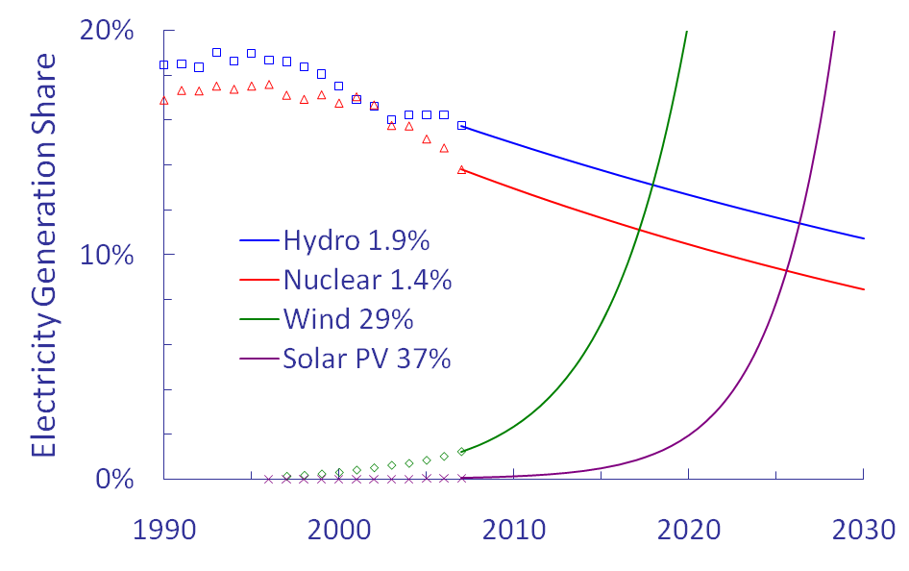

Concentrating Solar Thermal (Rutledge, 2008)
- 400 MW capacity, 5 GW planned
- Main materials are glass and aluminum ⎯ easy to manufacture on any conceivable scale, energy payback is a half year
- Plants are built in one or two years
- Efficient, inexpensive thermal storage
- Could scale up to cover most of the US energy needs
- Could get national coverage through DC transmissions lines from the Southwest ⎯ Cable loss is 4% per 1,000km, electronics loss at each end is 0.6%

The Ontario Government, in spite of favouring nuclear power, has given serious thought to integrating renewable energy in the future. (Ontario Energy 2007)
2007 Ontario Energy Mix(% of total)
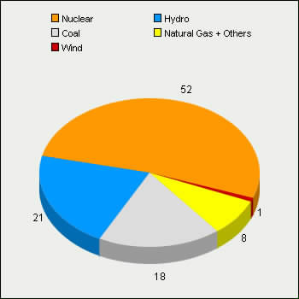

Why Ontario Needs to Renew Supply
While Ontario has more than 31,000 megawatts of electricity generating capacity, many existing power facilities are reaching the end of their operating lives, and as much as 80 per cent will need to be refurbished or replaced over the next 20 years.

Target Capacity Mix in 2025 (MW)
(Based on the Supply Mix Directive, June 2006)

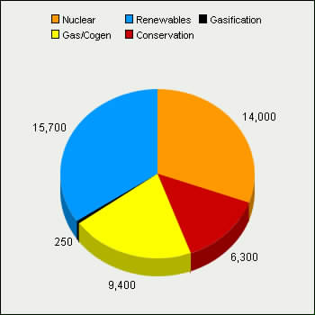

Conclusion
A peaceful sustainable civilization based on renewable energy resources without agrofuels and nuclear power is possible. For the sake of global justice, the rich must reduce per capita consumption, and world population must be reduced in a fair way. Urgent and dramatic change in technology is necessary. Implementation requires education of the educators, of the general public, and convincing the decision makers in industry and government. Global governance is required to protect the global commons by legislation and law enforcement, and local governments with guts are needed to implement changes.

References

Archer, Cristina L. and Mark Z. Jacobson (2005), Department of Civil and Environmental Engineering, Stanford University, Stanford, California, USA, “Evaluation of global wind power”, Journal of Geophysical Research, Volume 110, Issue D12. http://www.stanford.edu/group/efmh/winds/2004jd005462.pdf
Carter, Jimmy 1979, televised speech on July 15, 1979. http://www.pbs.org/wgbh/amex/carter/filmmore/ps_crisis.html
ECONOMIST, THE. 2007 , July 28, page 81,
“Where the wind blows”
Ehrlich, P.R and J. Holdren, (1971) The Impact of Population Growth, Science, Vol. 171, p.1212
Global Footprint Network (2008) http://www.footprintnetwork.org/gfn_sub.php?content=app_carbon_footprint
Intergovernmental Panel on Climate Change (2007), http://www.ipcc.ch/ipccreports/assessments-reports.htm
International Geothermal Association (2005)
http://iga.igg.cnr.it/index.php
King James Bible, Genesis, 9:1
“And God blessed Noah and his sons, and said unto them, Be fruitful, and multiply, and replenish the earth”
Ontario Energy 2007 http://www.energy.gov.on.ca/index.cfm?fuseaction=electricity.nuclear_supply
Rutlege, Dave, 2008 Powepoint slides,
http://rutledge.caltech.edu/
Schmidt Bleek, Friedrich, The Factor 10 Institute (2008),
http://www.factor10-institute.org/about.html#factor10_institute
US Government website (2008): Survey of geothermal energy potential.
http://www.america.gov/st/env-english/2008/February/20080206161409lcnirellep0.5360224.html
Weizsäcker, Ernst Ulrich von, Amory und Hunter Lovins (1998), "FACTOR FOUR - Doubling Wealth, Halving Resource Use", Earth Scan, Stirling, Virginia, USA.
Westra, Laura, Klaus Bosselmann, and Richard Westra Editors, “Reconciling Human Existence With Ecological Integrity”, Part 4, “Ecological Integrity, Climate Change, and Energy”, Earthscan, Stirling, Virginia, USA, 2008.
Wikipedia 2008: on the power of the sun
http://en.wikipedia.org/wiki/Solar_energy#Energy_from_the_Sun
Wikipedia 2008 b: on dual use of technology
http://en.wikipedia.org/wiki/Dual_use_technology
World Geothermal Congress 2005 Recommendations can be found at: http://iga.igg.cnr.it/documenti/IGA/WorldGeothermal2005_Findings.pdf

